Title

MrBlob37’s Life Crystals mod wiki

**Getting Started 2**

**Found in structures 2**

**Dropped from bosses 4**

**Crafted 5**

# Getting Started

To get started, there are some thing that you need to know:

1. All crystals can be acquired by:

a) Finding them in structures

b) Getting them from bosses

c) Crafting them

1. You can have maximum up to 10 additional hearts

# **Found in structures**

1. Default life crystal:  
   Can be found in abandoned mineshafts and needs to be fixed in order to be usable  
   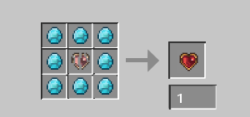
2. Golden life crystal:  
   Can be found in desert pyramids and needs to be fixed in order to be usable  
   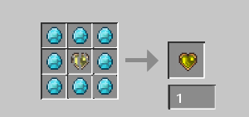
3. Amethyst life crystal:  
   Can be found in pillager outposts and needs to be fixed in order to be usable  
   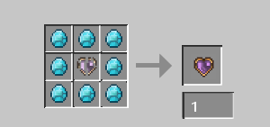
4. Emerald life crystal:  
   Can be found in woodland mansions and needs to be fixed in order to be usable  
   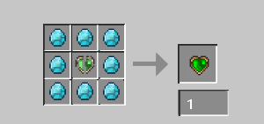
5. Lapis life crystal:  
   Can be found in end cities and needs to be fixed in order to be usable  
   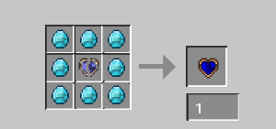
6. Diamond life crystal:  
   Can be found in shipwrecks and needs to be fixed in order to be usable  
   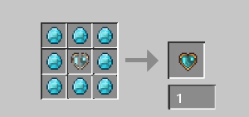
7. Heart of fire:  
   Can be found in nether fortresses
8. Heart of the ocean:  
   Can be found in buried treasures

# **Dropped from bosses**

1. Dragon’s heart:

Made from the dragon’s soul, which is dropped from the ender dragon  
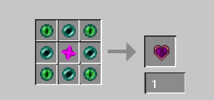

1. Withered heart:

Made from the nether star, which is dropped from the wither  
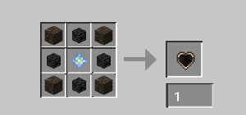

1. Heart of the sculk:

Dropped from the warden and needs to be fixed in order to be usable

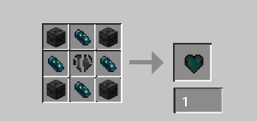

1. Heart of the elder guardian:

Dropped from the elder guardian

# **Crafted**

1. Netherite life crystal:

Made from the diamond life crystal, netherite ingot and netherite upgrade

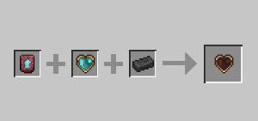

1. Royal heart:

Made from the golden life crystal, 3 red diamonds and 5 gold ingots

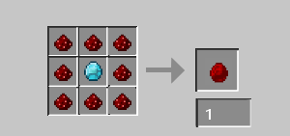

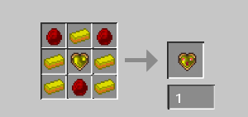

1. Heart of many lives:

Made from the life crystal, gold life crystal, diamond life crystal, netherite life crystal, 2 red diamonds, 2 diamonds and a nether star:

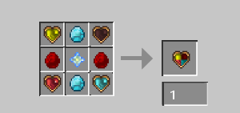

1. Magic life crystal:

Made from 4 enchantement books, 4 lapis lazuli and lapis life crystal:

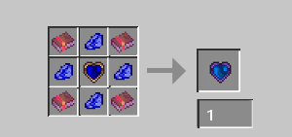

1. Healthbreaker:

Made from 8 iron ingots and coal:

